**Lab – 30: Set instant visibility, protection, and governance actions for your apps.**

**Objective:** The objective of this lab is –

* To set instant visibility, protection, and governance actions for the apps.

App connectors leverage the APIs of app providers to enable greater visibility and control by Cloud App Security over the apps you connect to. After you connect an app, you can gain deeper visibility so you can investigate activities, files, and accounts for the apps in your cloud environment. In this lab, we are going to set instant visibility, protection, and governance actions for the apps.

**Prerequisite:** EMS Enterprise Mobility + Security E5. To set up Cloud App Security, you must be a Global Administrator, a Compliance Administrator or a Security Reader in Azure Active Directory or Office 365.

**Steps:**

1. To access the Cloud App Security portal, go to <https://portal.cloudappsecurity.com>.

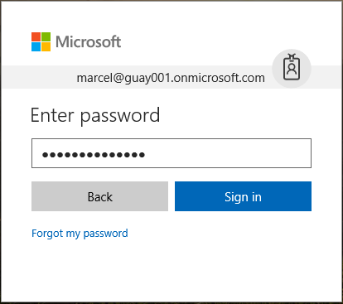

1. When you sign-in to Cloud App Security a general dashboard will be shown.
2. Go to **Settings** > **App connectors** under Sources.

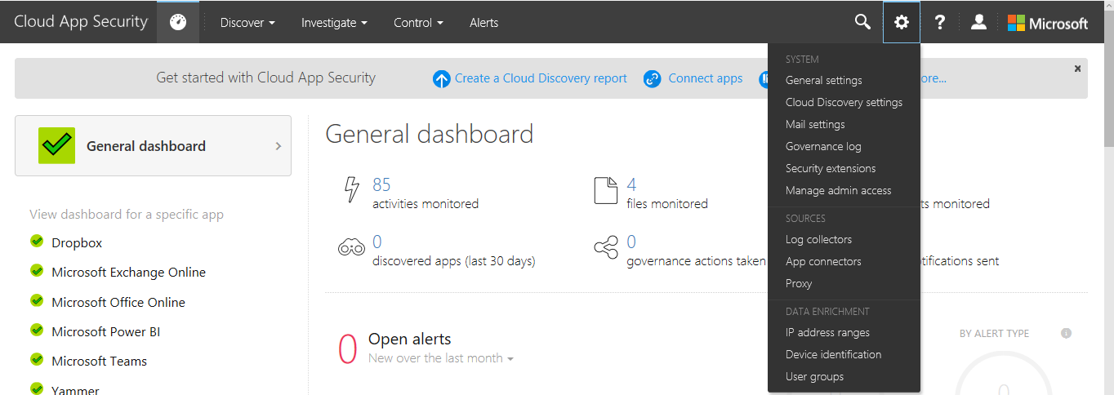

1. Right now, no connected apps found. To connect an app, click (**+**) icon and select an app that you want to connect from the list. Select **Dropbox**.

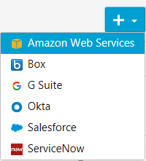

1. After selecting, a pop-up page will open from where you can connect Dropbox. You can **connect Dropbox to enable instant visibility, protection and governance action**. Click **Connect Dropbox**.

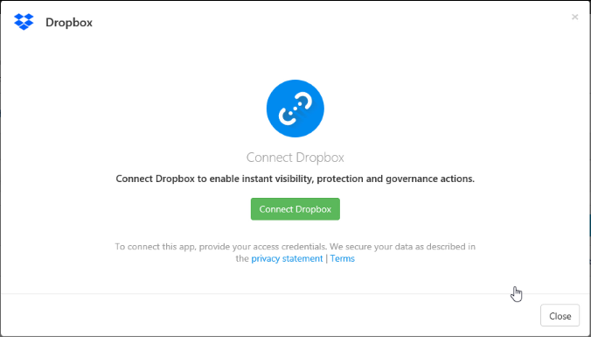

1. Now you need to enter details to create an OAuth token for Dropbox. Enter your Admin account. Then click **Save settings**.

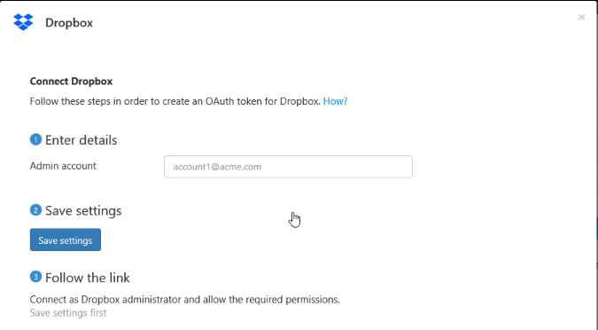

1. **Dropbox settings saved successfully,** message will be shown. Also, you can follow the link, to connect as Dropbox administrator and allow the required permissions. Then click **Close**.

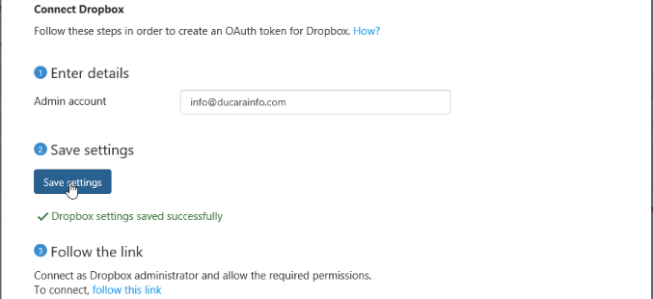

1. In the same way, connect more apps to set instant visibility, protection, and governance actions for those apps.
2. After refreshing the page, you will get all the connected apps on the **Connected apps** screen.

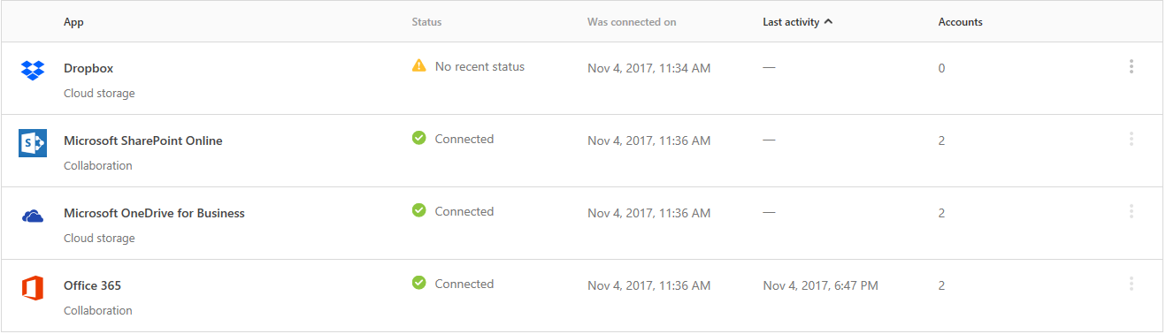

1. Click any app, to view the complete details like – Status, was connected on, Last health check, connected by, Protected accounts, Last activity log, Files scanned for DLP (last 24 hours) and Real-time scan status.

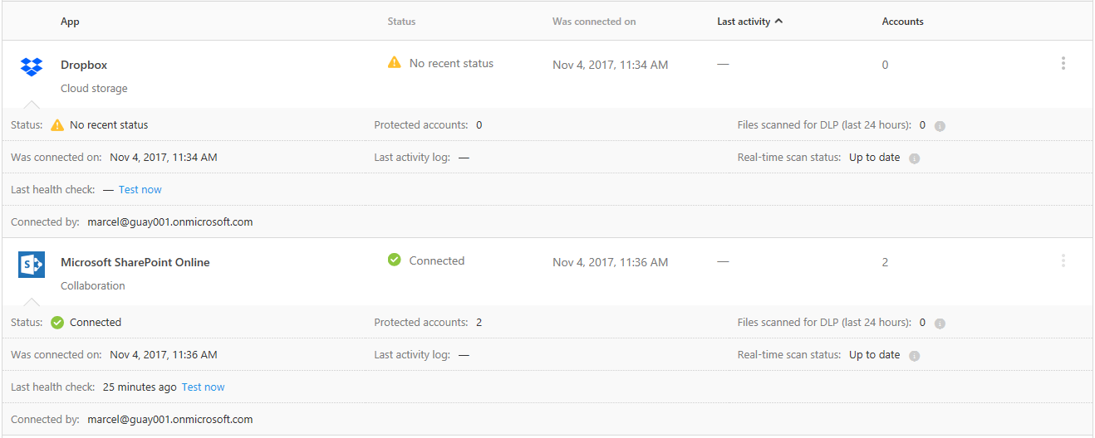

1. So, in this way you can set instant visibility, protection, and governance actions for the apps.